A Project on

College Management System

College Management System

ACKNOWLEDGEMENT

TABLE OF CONTENTS

- Project Profile

- Project Definition
- Objective & Scope
- Tools & Technology
- Overview of Tools

- Project Management

- Project Management Techniques
- Activity Chart

- System Analysis

- Feasibility Analysis
- Requirement Analysis
- Requirement Specification

- System Design

- Structured Analysis & Design
- DFD
- Data Dictionary

- Input & Output Screen

- Software Development Specification

- Hardware Specification
- Software Specification

- Limitation & Future Enhancements

- Conclusion

- Bibliography

PROJECT DEFINITION:

Good management helps organization to lead among competitor. Management made our work silky, made our work trouble-free and speedy. Today’s life is so busy and organizations have less time for maintaining their important work. So, to make life easy for organizations we make a small web service for College Management System. It gives facility to do personal & professional work online easily and speedy.

OBJECTIVE:

College Management System is a full-featured application designed specifically for planning, managing, and scheduling College’s important dates and times. It runs in the background, sits in the system tray, and makes it nearly impossible to forget record, entry, scheduling, meetings, and other important events.

Using this web based application organisation can explain rationale, roles, responsibility for reviews, performance management cycle, managing weak performance, confidentiality. The main objective is user convenience College Management System.com provides easy user interface, simple processing, and easy to use application.

SCOPE OF PROJECT:

College Management System is web applications from which any organization can manage important work i.e. personal/professional. Organisation work would be managed by registered user. Administrator can enter record, edit record, and manage student as well as faculty information. Also user can make group for intercommunication and can send his/her mail to the selected members of group.
TOOLS & TECHNOLOGY:

FrontEnd Contains:
-- Asp.Net 2.0
BackEnd Contains:
-- Microsoft SQL Server 2005

Overview of Tools:

Front-End:

Asp.Net 2.0 and C# 2.0
ASP.NET is a unified Web development model that includes the services necessary for you to build enterprise-class Web applications with a minimum of coding. ASP.NET is part of the .NET Framework, and when coding ASP.NET applications you have access to classes in the .NET Framework. You can code your applications in any language compatible with the common language runtime (CLR), including Microsoft Visual Basic, C#, JScript .NET, and J#. These languages enable you to develop ASP.NET applications that benefit from the common language runtime, type safety, inheritance, and so on.
ASP.NET includes:

- A page and controls framework
- The ASP.NET compiler
- Security infrastructure
- State-management facilities
- Application configuration
- Health monitoring and performance features
- Debugging support
- An XML Web services framework
- Extensible hosting environment and application life cycle management
- An extensible designer environment

ASP.NET:

ASP.NET provides a unified Web development model that includes the services necessary for you to build enterprise-class Web applications. ASP.NET is part of the .NET Framework and enables you to take full advantage of the features of the common language runtime, such as type safety, inheritance, language interoperability, and versioning.
The topics in this section provide you with conceptual information about how ASP.NET works and procedural topics that show you how to write code that take advantage of the power of ASP.NET to create dynamic Web applications.
Why is ASP.Net 2.0 proffered?

The Microsoft .NET Framework version 2.0 includes significant enhancements to ASP.NET in virtually all areas. ASP.NET has been improved to provide out-of-the-box support for the most common Web application situations. You will find that you can get Web sites and pages up and running more easily and with less code than ever before. At the same time, you can add custom features to ASP.NET to accommodate your own requirements.

Specific areas in which ASP.NET has been improved are:

- Productivity: You can easily and quickly create ASP.NET Web pages and applications using new ASP.NET server controls and existing controls with new features. New areas such as membership, personalization, and themes provide system-level functionality that would normally require extensive developer coding. Core development scenarios, particularly data, have been addressed by new data controls, no-code binding, and smart data-display controls.

- Flexibility and extensibility: Many ASP.NET features are extensible so that you can easily incorporate custom features into applications. The ASP.NET provider model, for example, provides pluggable support for different data sources.

- Performance: Features such as recompilations, configurable caching, and SQL cache invalidation allow you to optimize the performance of your Web applications.

- Security: It is now easier than ever to add authentication and authorization to your Web applications.

- Hosting: ASP.NET includes new features that make it easier to manage a hosting environment and create more opportunities for hosters to add value.

- Completeness: New and existing features work in concert to allow you to create end-to-end scenarios that address real-world Web development challenges.

The following sections describe changes made in different areas of ASP.NET:
- Web Site Management
- Page Design
- Controls
- Data
- Security

1. Web Site Management:

Web site configuration is improved to include many more settings. You can easily manage application settings using the Web Site Administration Tool, which provides a wizard-like interface for setting up and maintaining your applications. The Web Site Administration Tool is particularly useful for managing remote sites (for example, sites that are hosted by an ASP.NET-compatible ISP).
If you host sites for others, you can use a new ASP.NET Microsoft Management Console (MMC) plug-in or an administrative API to manage sites and monitor their health. You can add value to your hosting site by offering controls or services that you can selectively enable or disable.

1.1 New Administration Features and Tools:
ASP.NET includes features to make Web site management easier for both Web site developers and for administrators. Configuration files include a richer set of elements that give site developers control over new features and finer control over existing ones. A new configuration API makes it possible to control configuration programmatically. New tools provide a GUI interface for configuring applications — the new Web Site Administration Tool makes it easy for Web site developers to manage their own sites using a Web-based interface (both locally and remotely), and an ASP.NET-specific MMC snap-in allows site administrators to manage complex configuration scenarios using a standard Windows server-based tool.

1.2 Reserved Folders for Special Functionality:

Web sites can include an App_Code folder into which site developers can put source code that is then compiled automatically as part of the Web site, making it unnecessary to compile components or controls before using them in a site. An App_Data folder is reserved for databases (for example, SQL Server Express Edition .mdf files). Special folders for resources contain XML-based files containing strings and other resources for localization, which are dynamically compiled into assemblies at runtime.

1.3 Recompiling Web Sites for Error Checking and Deployment
You can now precompile your Web site, which allows you to enhance performance by avoiding the overhead of dynamic compilation and allows you to catch compile-time errors. You can also precompile a site for deployment, producing a version of the site that you can easily copy to or install on a production server. Precompiling for deployment strips source code, which helps you protect your intellectual property.

1.4 Navigation
You can add site navigation to your Web sites by defining a site map (typically an XML file). You can then use new navigation controls such as the TreeView and SiteMapPath controls that can automatically create a menu or tree view of pages, or that can display a navigation path (also known as a breadcrumb) showing the current page hierarchy.

2. Page Design
New features of ASP.NET help you easily create pages that are more consistent and can offer a richer experience to users.

2.1 Consistent Layout using Master Pages
You can use master pages to create a consistent page layout for your Web site or for a group of related pages. On the master page, you define a common look; you can then create individual content pages that provide the dynamic content that is displayed using the master page as a template

2.2 Themes for Consistent Appearance
Themes allow you to create a consistent look for your site. A theme contains a collection of control skins that define property settings (such as background color and font), CSS style settings, and images to specify the appearance of a control.

2.3 New Code-Behind Model for Pages
ASP.NET continues to support the single-file model from the previous version of ASP.NET and now includes a new code-behind model. The new model allows you to use a new .NET Framework feature, partial classes, to create a code file with just the code in it that you need, such as event handlers. The end result is a clean separation of the markup from the code in a page, and a robust model for managing a page’s code.
2.4 Users-Customizable Web Pages

With Web parts, you can create modularized Web pages that users can customize extensively. A Web part incorporates a discrete piece of functionality, such as a weather report, a stock ticker, or a window for reading news. ASP.NET allows you to create your own Web parts. You can then create Web pages that include a selection of Web parts. Using the Web parts architecture, you can allow users to customize individual Web parts (for example, by typing in a ZIP code to display local information) and change the layout of Web parts. You can also allow users to add and remove Web parts, thereby giving users the ultimate flexibility in using your site

2.5 User-Specific Values
You can provide users with a custom experience in your Web site by defining and using profile properties, which you can use to track user information (address, city), preferences (color scheme, list of stocks to follow), or any custom information required by your application (shopping cart). Once you have defined profile properties, ASP.NET automatically associates individual instances of the profile properties with each user, and you can use code to set or get the values. ASP.NET persists property values in a data store (which you can configure), and the next time a user visits your site, ASP.NET automatically retrieves the profile property value for that user.

2.6 New Caching Features
Enhancements to caching help you increase the performance of your site and manage more precisely. You can manage caching at the Web site level using Web.config settings, rather than managing it at the page level. You can now invalidate cache contents programmatically. If you are using SQL Server 7.0 or later, you can set up a cache dependency based on a SQL Server database table so that when the table changes, the cache entry dependent on it is made invalid.

2.7 Enhanced Client-Side Functionality
ASP.NET pages make it easier to add client-side functionality to pages to enhance the run-time experience for users. You can more easily bind client-side event handlers to controls and add better support for accelerator keys. For multi-page forms, you can use the new Wizard control, or you can take advantage of the new cross-page-posting facility in Web pages.

3. Control
ASP.NET features many improvements to Web server controls, including both enhancements to existing controls and a selection of new controls.

3.1 General Control Improvements
A major area of enhancement in ASP.NET 2.0 is in the controls you use to create ASP.NET Web pages. General improvements to controls include:

- By default, controls now generate markup that is compatible with the XHMTL 1.1. Standard.

- All controls support adaptive rendering, and can emit markup that is appropriate for the requesting browser.

- All data controls can use either the new data-binding model with data source controls, or can continue to use the model used in earlier versions of ASP.NET.

- All controls support themes and skins so that you can customize their appearance using an ASP.NET theme

- You can use device filtering with many control properties, specifying different property values for different devices. When the control is rendered, the appropriate property value is set based on the requesting browser.

- Validation controls can now be grouped, which allows you to selectively enable validation for some controls.

- Improvements to individual controls such as the Label control, List Box control, and others to add functionality often requested by developers

3.2 New Controls
ASP.NET offers a greater selection of controls to help you create fully featured Web pages much more quickly. You can now take advantage of the following controls:

- Navigation. You can add navigation paths (also known as breadcrumbs) to pages with the SiteMapPath control and display a site map using the TreeView control.

- Security. You can authenticate users with a suite of login controls that allow you to get and validate user credentials, display custom output for logged-in users, and more.

- Web Parts. A new set of Web Part controls allow you to create portal pages that users can personalize at run time. For example, you can create a Web Part that allows a user to enter a custom value such as a postal code and get localized weather reports.

- Client behavior. New controls provide ASP.NET server control functionality for tasks that previously was handled only by HTML elements. These include the FileUpload control, ImageMap control, and the HiddenField control.
- The new Wizard controls allow you to create a page with multiple panels that step the user through multi-part forms.

In addition, existing ASP.NET controls have been enhanced with new features. All controls now support the new data-binding model, themes, and personalization.
You can also use all controls to create pages for devices; controls now automatically support adaptive rendering and device filtering.

4. Data
ASP.NET includes substantially improved support for working with data in your Web applications.

4.1 Data Source Controls
For binding data to controls on Web pages, you can now use data source controls, which encapsulate connections, query commands, and parameters into a single control. ASP.NET includes data source controls that work with a variety of back-end data sources, including Microsoft SQL Server, Microsoft Access, XML files, Web services, FrontPage site maps, and business objects that return data sets. All data source controls support the same basic object model, giving you a consistent way to work with data regardless of its source.
Data source controls can automatically fetch data and manage it when the page runs. You no longer need to write code to execute commands and manage datasets for common data scenarios. However, if your application requires it, you still have access to the lower-level data functions exposed by ADO.NET.
To pass parameters to data source controls, you can configure the controls to draw parameters values from other controls, Session state, query strings, or cookies; in addition, you can set parameter values programmatically.

4.2 Middle-Tier Data Access
By using the new Object Data Source control, you can easily add data access to a page that is based on a middle-tier business object. The Object Data Source exposes the same binding interface to controls on the page, but instead of performing direct database access, it invokes methods on a component that you specify.

4.3 Data Display Controls
ASP.NET also includes enhanced support for displaying and updating data with controls on Web pages. All controls can now use data source controls as data source instead of working directly against a dataset or other store. You can also take advantage of the following new controls that are specifically built to make data access easier:

- The GridView, DetailsView, FormView controls to display and edit data. (The GridView control supersedes the DataGrid control from previous versions of ASP.NET.)

- The TreeView control to display hierarchical information from XML files, sitemap files, and relational data sources.

- The SiteMapPath and Menu controls to provide data-bound support for navigation.

4.4 XML Support
You can use XML data in a variety of ways in ASP.NET. An XML data source control exposes XML data to be used either as hierarchical or tabular data. You can bind a TreeView control to XML data to provide a hierarchical view for users, or you can bind a list control such as the GridView control to display XML in a traditional way.

4.5 Connection String Storage
To enhance Web site security, you can store connection strings in a dedicated section of the configuration file.

5. SECURITY

New ASP.NET features provide built-in support for authenticating and authorizing users. ASP.NET membership manages authentication, providing facilities for validating user credentials and helping users manage their passwords.
The membership service provides APIs that you can call programmatically to create new users, validate credentials, and get user information. To simplify authentication even more, you can use the new login controls, which work with the ASP.NET membership to perform a variety of tasks, often with no extra code required. The Login control prompts users for credentials and validates them. The PasswordRecovery control provides various options for helping users either change or remember their password. You can display user information with the LoginName control, and present a Login or Logout button using the LoginStatus control. The LoginView control allows you to mark content in a page that is visible only to authenticated users.
ASP.NET role management helps you manage authorization, providing high-level ways for you to define and check roles for users.
Both the membership and role management systems use the new ASP.NET provider model, which separates the functionality of the systems from the data store that supports them. For example, membership allows you to store user information in Microsoft SQL Server or Microsoft Access. If these default options are not suitable for your requirements, you can create your own provider that accepts calls from membership and then fulfills them using your custom data logic.

Microsoft’s C#.Net

An ASP.NET page is restricted to code written in a single programming language. Currently, ASP.NET supports Visual Basic, C#, and J#. The default language is Visual Basic, but any other language can be declared as the default language for the page by placing a directive at the top of the page, such as the following:
<%@Language="C#"%>
The language can also be declared in a <script language = …> block, as in the example provided in Code Blocks in ASP.NET. If different languages are declared in separate script blocks on the same page, an error will be thrown.
Although only one language can be used on a single page, any user controls that you use on a page can be written in different languages, including Visual C++. This allows applications to take advantage of function libraries in different languages.
Visual Basic Scripting Edition (VBScript) is not supported, but VBScript syntax is very similar to Visual Basic 2005 syntax, so any required changes to existing code should be minor.

Back-End:

Microsoft SQL Server:
Microsoft SQL Server is a set of components that work together to meet the data storage and analysis needs of the largest Web sites and enterprise data processing systems. Microsoft SQL Server 2005 data is stored in databases. The data in a database is organized into the logical components visible to users. A database is also physically implemented as two or more files on disk.
Each instance of SQL Server has four system databases (Login, Registered and Rem) and one or more user databases (Grp and Mbr). Some organizations have only one user database, containing all the data for their organization. Some organizations have different databases for each group in their organization, and sometimes a database used by a single application. For example, an organization could have one database for sales, one for payroll, one for a document management application, and so on. Sometimes an application uses only one database; other applications may access several databases.
It is not necessary to run multiple copies of the SQL Server database engine to allow multiple users to access the databases on a server. An instance of the SQL Server Standard or Enterprise Edition is capable of handling thousands of users working in multiple databases at the same time.

Database Architecture:
Microsoft SQL Server 2005 data is stored in databases. The data in a database is organized into the logical components visible to users. A database is also physically implemented as two or more files on disk.
When using a database, you work primarily with the logical components such as tables, views, procedures, and users. The physical implementation of files is largely transparent. Typically, only the database administrator needs to work with the physical implementations
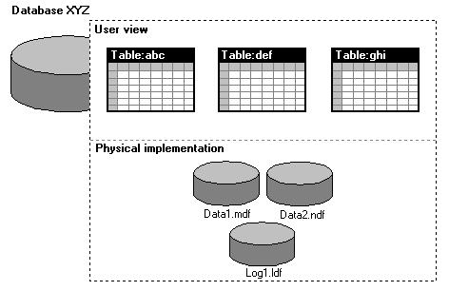

PROJECT MANAGEMENT TECHNIQUES

Project management techniques are used for maintenance of the project, meet the project dead lines, and minimum effort required from the company employee.

Project Planning

The purpose of Project Planning is to identify the scope of the project, estimate the work involved, and create a project schedule. Project planning begins with requirements that define the software to be developed. The project plan is then developed to describe the tasks that will lead to completion.

Project Monitoring and Control

The purpose of Project Monitoring and Control is to keep the team and management up to date on the project's progress. If the project deviates from the plan, then the project manager can take action to correct the problem. Project monitoring and control involves status meetings to gather status from the team. When changes need to be made, Change control is used to keep the products up to date.

Software Requirements

Requirements analysis is a term used to describe all the tasks that go into the instigation, scoping and definition of a new or altered computer system. Requirements analysis is an important part of the software engineering process; whereby business analysts or software developer identify the needs or requirements of a client.

ACTIVITY CHART

Week | 1 | 2 | 3 | 4 | 5 | 6 | 7 | 8 | 9 | 10 | 11 | 12 | 13 | 14 | 15 | 16
Date | 13 | 20 | 27 | 3 | 10 | 17 | 24 | 1 | 8 | 15 | 22 | 29 | 5 | 12 | 19 | 26
Month  Activity | July |  |  | August |  |  |  | September |  |  |  |  | Octomber
Analysis
Learning
Process
Design
Coding
Documentation

Feasibility study

Feasibility study is the likelihood the system will be useful to organization. After studying the requirements, whether the proposed project is feasible or not, is determined by checking the various feasibilities. The three aspects in the feasibility study portion of preliminary investigation are:

Technical Feasibility
Technical feasibility corresponds to determination of whether it is technically feasible to develop the software.
- Necessary technology exists to do what is suggested and required by the organization.
- The proposed equipments have the technical capacity to hold the data required to use the new system.
- The proposed system will provide adequate response to inquiries regardless of the location if users.
- The hardware needed to develop and implement the system is adequate.
- The software guarantees accuracy, reliability and ease of access and data security.

Economic Feasibility
A system that can be developed and that will be used if installed must still be a good investment for the organization. Financial benefits must equal or exceed the costs.
The financial and economical issues raised are as under:
- No extra cost is incurred for developing the system. As required software are already used by the department.
- No extra cost for the modification or addition of software and hardware will require in case of future expansion of the current system.
- As the project is to be developed by trainees the cost incurred by the company is in the form of resource allocation rather than monetary. The cost on the company is indirect in the form of resources utilization.
- The company will be at profit if they implement this system because of the cost of implementation is nominal as compared to the profit they will be earning in terms of efficiency.
Considering above factors project is economically feasible.

Operational Feasibility
Operational feasibility focuses on whether the system will work when it is developed and installed. Operationally the system is feasible because:
- There is sufficient support for the project from management and user. The system is well liked and used to the extent that persons will not be able to see reasons for change.
- The current business methods are not acceptable because the manual system is time consuming. The users though initially repressive worked along with the development team once the initial doubts were cleared.
- The users have been involved in the planning and development of the project. This reduces the chances of resistance to the system.
- The proposed system will not cost any harm to the existing system and its users.
- No special training required for the user as it has a self explanatory interface. Validation of data input is taken care of by the system and not by the user.
Since the most trivial of issues assumes a major problematic state later in the development cycle, every possible aspect of operational feasibility was checked. The proposed project passed all the feasibility tests and hence was declared feasible to organization and its functioning.

Time Schedule Feasibility
Time is the most affecting factor while making a project or a system like this one. The project should be finished within the assigned time. Otherwise the whole project will be delayed and that is disastrous for a project developer and project leader also.

Implementation Feasibility
Implementation feasibility is also a very effecting factor while for a new system. The project manager will check whether the developer can make the project in time with the specified requirements and best performance. The project leader will also check that the given tools and technologies to the developer will make the system a success or not.

Requirement Analysis

Software requirement analysis is the activity of eliciting, analyzing and recording requirement for software system. It shares much in common with requirement analysis for more general kinds of systems. But has its own specific approaches.

Eliciting Requirement:
Requirement elicitation is the task of communicating with customers and users to determine what their requirements are.

Analyzing Requirement:
The true analysis part of requirement analysis locates palaces where requirements are unclear, incomplete or ambiguous. Requirements analysts work with customer representatives to resolve these issues, sometimes preparing tradeoff studies to compare alternatives. The purpose of analysis activity is to transform candidate technical requirements into formal requirements by ensuring that they express the needs of the customer.

Analysis is an iterative activity. The process steps will likely to be repeated several times, with consultation between customers, end users and developers during each iteration and communication through the steps.

REQUIREMENTS SPECIFICATION

A software requirements specification (SRS) is a complete description of the behavior of the system to be developed. It includes a set of use cases that describe all of the interactions that the users will have with the software. In addition to use cases, the SRS contains functional requirements and nonfunctional requirements. Functional requirements define the internal workings of the software: that is, the calculations, technical details, data manipulation and processing, and other specific functionality that shows how the use cases are to be satisfied. Nonfunctional requirements impose constraints on the design or implementation (such as performance requirements, quality standards, or design constraints).

STRUCTURED ANALYSIS AND DESIGN TECHNIQUE

Analysis Methodology

The structured analysis concept employed in the development involved the presentation of system requirements in an easily derived and documented context. The Data Flow Diagram (DFD) represents logical decomposition of system requirements they are valuable in providing a succinct. Readily understood requirements representation, one which is directly communicated to non programmer system users and one which provides an invaluable pre design analysis tool. E R diagrams and data dictionaries have been used as system requirement specification devices.

Design methodology

The developments life cycle has effective used powerful software engineering management and development plans. System design methodology input/process/output charts have been used for top-down hierarchy charts. Structured design techniques and pseudo code have been used for system design. Implementations and test phases to ensure adherence to specifications and completeness of the system. Rigorous configuration control has been employed during the software enhancement and the maintenance phase. The current production versions are archived and backed up. Then, the software enhancements are produced and tested independent of the existing operational system. The updated version implemented after thorough parallel testing and approval. Documentation for the system has also been maintained under the configuration management. The changes are tightly controlled to ensure the impact in all areas. The technical approach followed the parallel chain of each of the approaches through the business planning, requirement analysis, general design, database design and detailed design.

Data Flow Diagram

Context Diagram

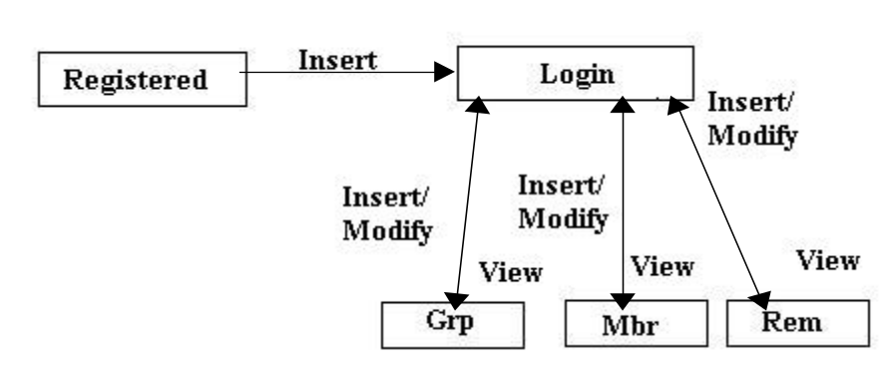

Level 1 Diagram

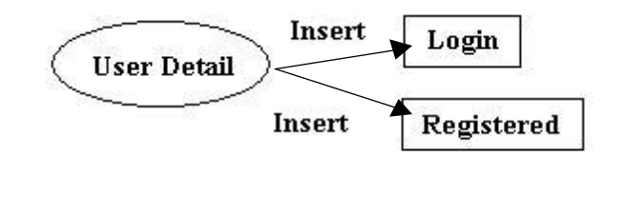

Process 1.1

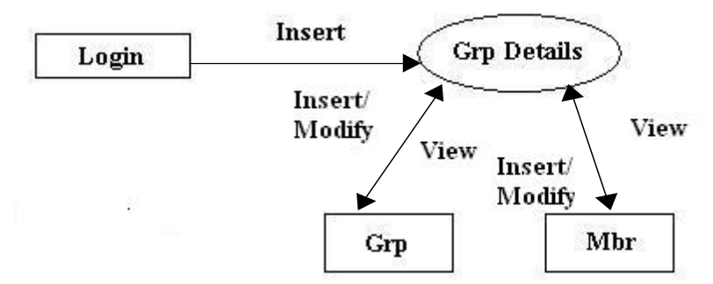

Process 2.1

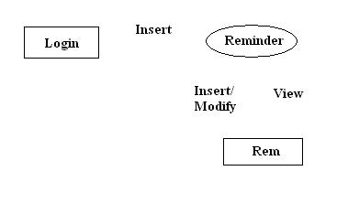
Process 3.1

DATA DICTIONARY

Admin_Login

Login
Name | Type | Constaint | Description
ID | Int | P.K. | Auto generated ID
Username | Varchar(50) |  | User Name
Password | Varchar(50) |  | Password of User

This table is used to maintain the information of the user’s login.

Dept

Department
Name | Type | Constraint | Description
ID | Int | P.K. | Auto generated Dept ID
ImgUrl | varchar(50) |  | Show Path to Choose Image
Name | varchar(50) |  | Department Name
Designation | Varchar(50)
Degree | Varchar(50)

This table is used to maintain the information of the various Departments.

Faculty_Detail

Faculty
Name | Type | Constraint | Description
ID | Int | P.K. | Auto generated ID of Faculty
RegNo | Varchar(50) |  | Faculty Registration Number
Name | Varchar(50) |  | Name of Faculty/User
LastName | Varchar(50) |  | Last Name of Faculty/User
Password | Varchar(50) |  | Require Password to Login as Faculty
Joining Date | Varchar(50) |  | Joining Date Of Faculty
Birth Date | Varchar(50) |  | Birth Date Of Faculty
Department | Varchar(50) |  | Department In Which Faculty Recruited
Post | Varchar(50) |  | Post On Which Faculty Recruited
Contact No | Varchar(50) |  | Mobile Number Of Faculty
Email ID | Varchar(50) |  | E-Mail ID Of Faculty
Photo | Varchar(50) |  | Photo Link Of Faculty

This table is used to maintain the information of the groups Member of Faculty.

Gallary

Gallary
Name | Type | Constraint | Description
ID | Int | P.K. | Auto generated ID for Photo
ImgUrl | Varchar(50) |  | Display Path to Choose Image
Category | Varcahr(50) |  | Name of Category for which this Photo belongs to

This table is used to maintain the detailed information of various category photo.

Mail

Mail
Name | Type | Constraint | Description
ID | Int | P.K. | Auto generated ID
SuserName | varchar(50) |  | Source
DuserName | varchar(50) |  | Destination
Message | varchar(50) |  | Contain Send To Member

This table is used to maintain the detailed information of mail facility.

News

Gallary
Name | Type | Constraint | Description
ID | Int | P.K. | Auto generated ID for Photo
Image | Varchar(50) |  | Display Path to Choose Image
Sdesc | Varcahr(50) |  | Small Description
Fdesc | Varcahr(50) |  | Full Description

This table is used to maintain the detailed information of desplay events & news.

Registration

Registration
Name | Type | Constraint | Description
ID | Int | P.K. | Auto generated ID of Faculty
RegNo | Varchar(50) |  | Faculty Registration Number
Name | Varchar(50) |  | Name of Faculty/User
LastName | Varchar(50) |  | Last Name of Faculty/User
UserName | Varchar(50)
Password | varchar(50) |  | Require Password to Login as Faculty
Category | Varchar(50)
Class | Varchar(50)
Joining Date | Varchar(50) |  | Joining Date Of Faculty
Birth Date | Varchar(50) |  | Birth Date Of Faculty
Department | Varchar(50) |  | Department In Which Faculty Recruited
Post | Varchar(50) |  | Post On Which Faculty Recruited
Contact No | Varchar(50) |  | Mobile Number Of Faculty
Email ID | Varchar(50) |  | E-Mail ID Of Faculty
Photo | Varchar(50) |  | Photo Link Of Faculty
Status | Varchar(50)

This table is used to maintain the detailed information of about the user registration.

Input/Output Screen Design

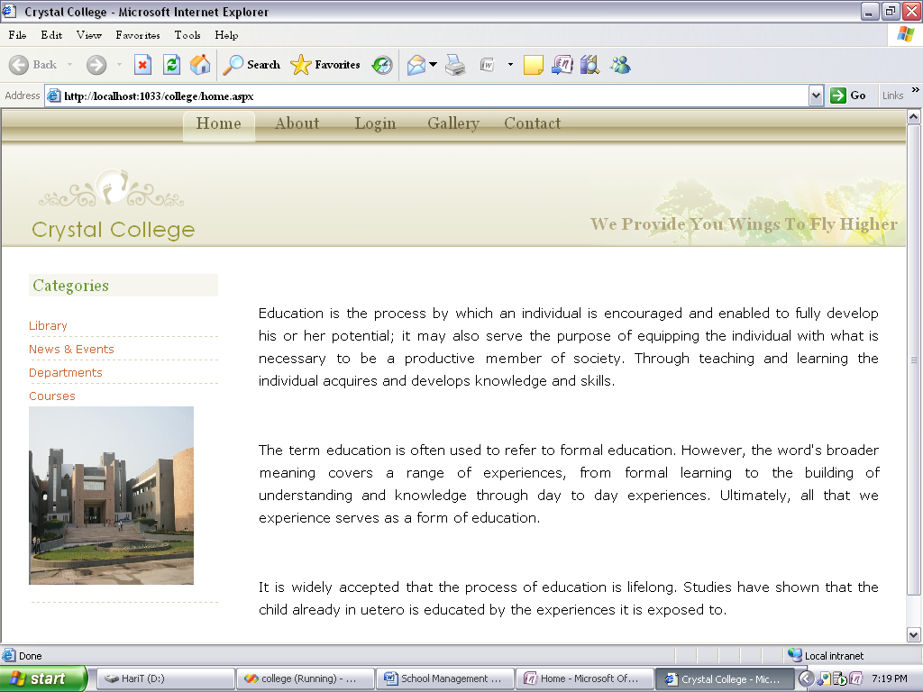

Home.aspx

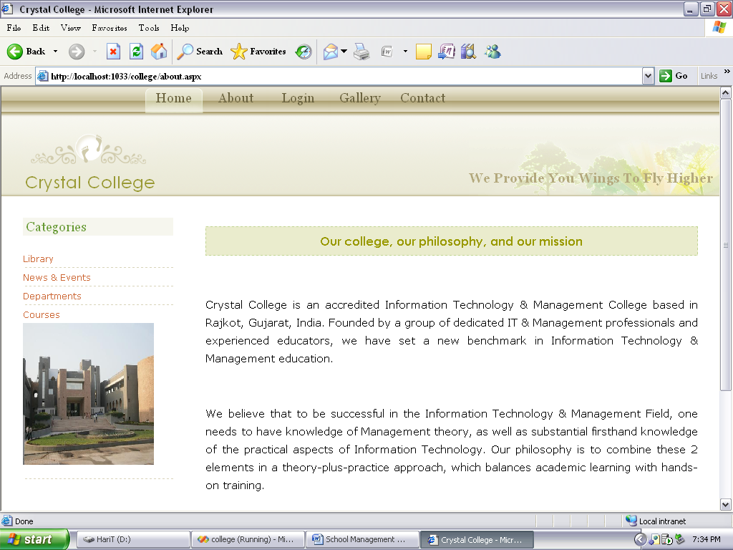

About.aspx

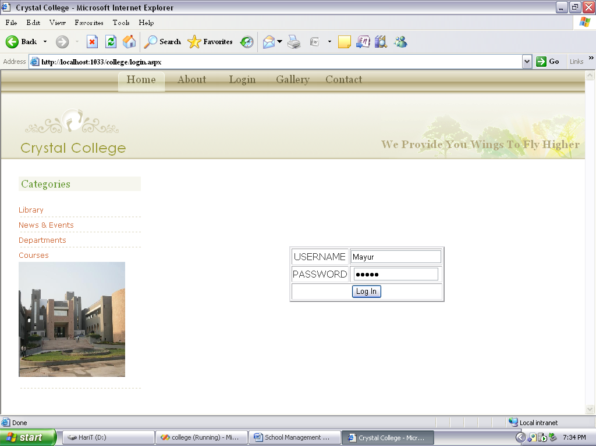

Login.aspx

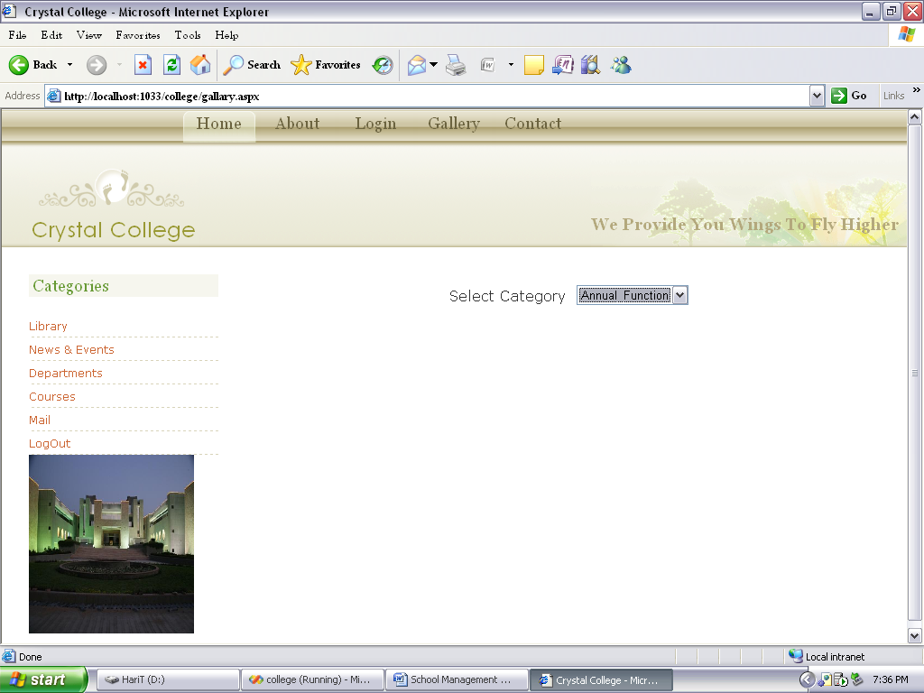

Gallery.aspx

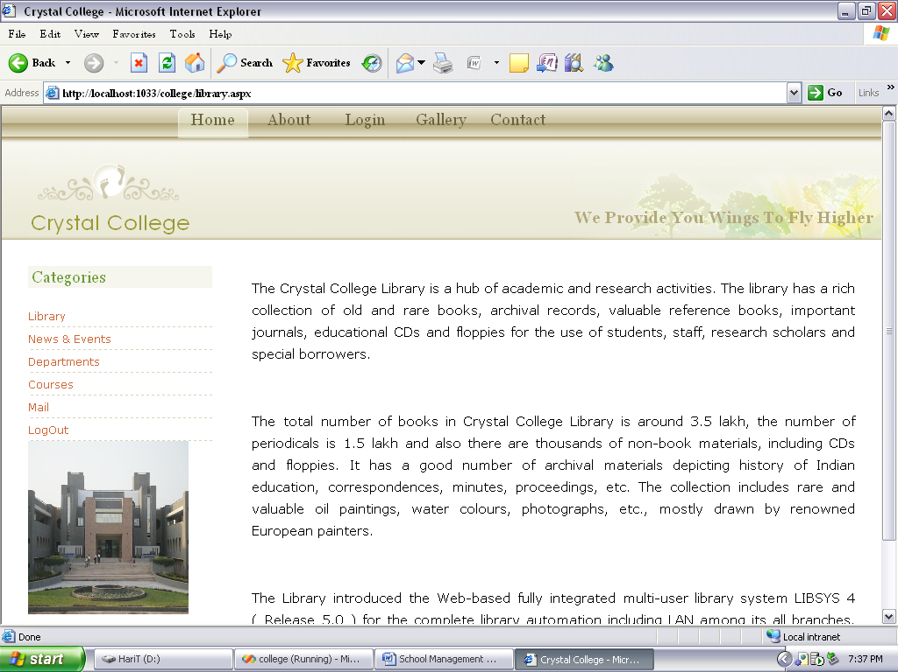

Library.aspx

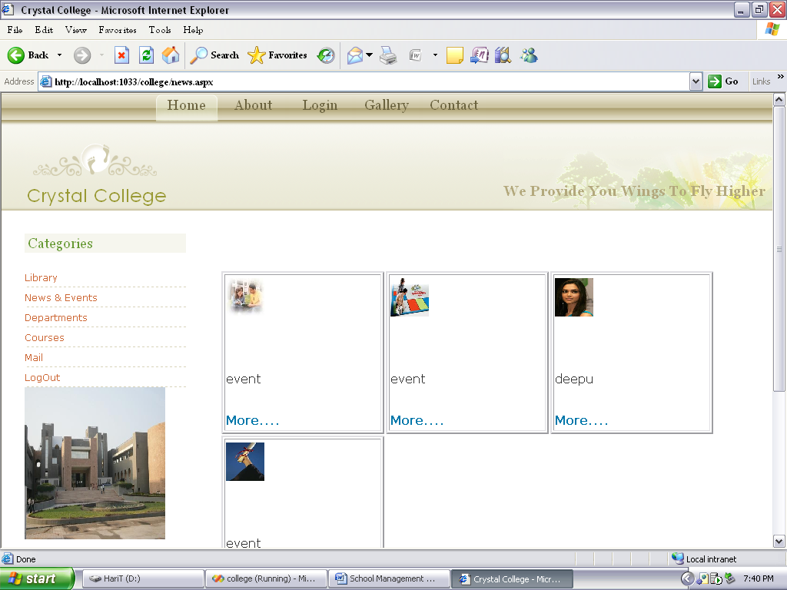

News & Events.aspx

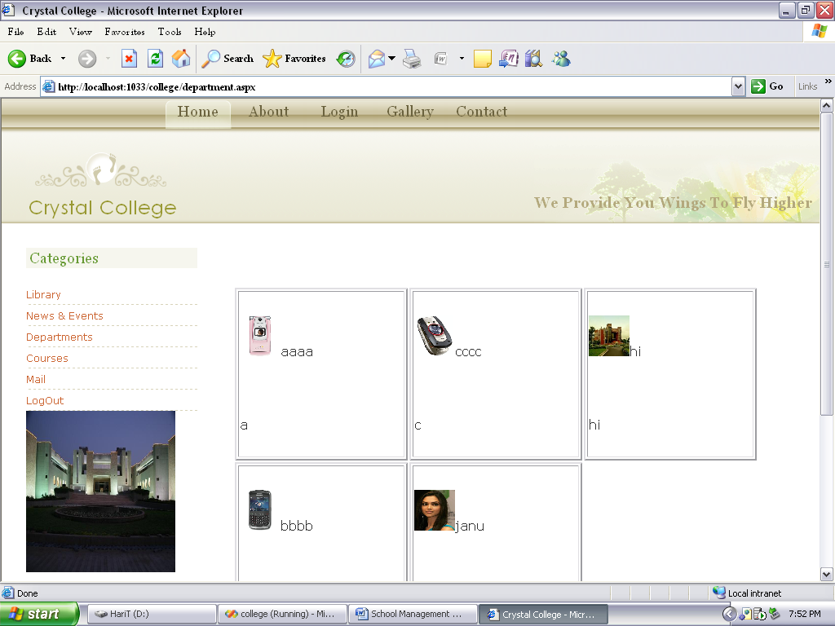

Department.aspx

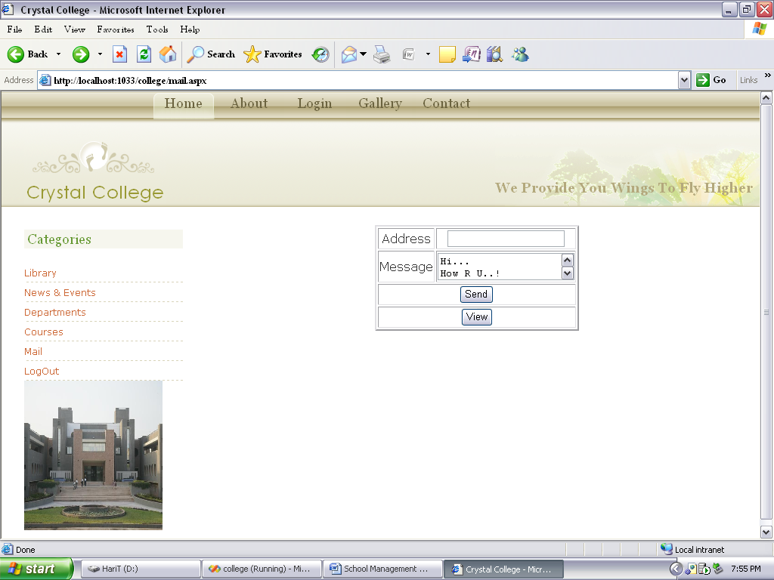

Mail.aspx

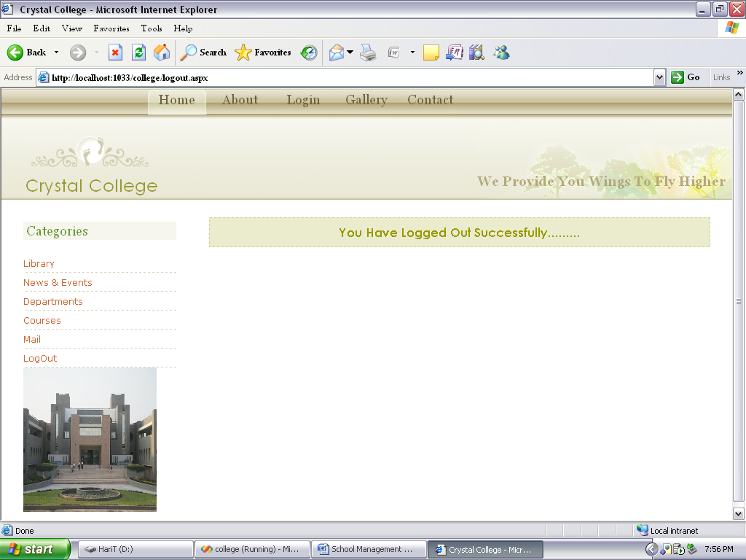

LogOut.aspx

Hardware and Software Requirements

Hardware requirements

Component | Development | Deployment
Computer System/  Processor | Pentium 4.1GHz processor | Pentium 4.1GHz processor
Hard Drive | 80 GB | 80 GB
RAM | Minimum 512 MB | Minimum 512 MB
Internet Connection | No | Yes
Printer | No | Yes

Software requirements

Component | Development | Deployment
Operating System | Windows XP Professional or later | Windows XP Professional or later
Database server | Microsoft SQL Server 2005 | Microsoft SQL Server 2005
Front End Tool | Asp.Net 2.0 | Internet Explorer

Limitations
- Web Application runs only on windows based operating system.
- This web application is static means not run on internet.

Future Analysis
- Student also edit, update their information.
- Student also made their community and mails each other.
- Student can upload their events photos.

CONCLUSION

The application works satisfactory. Using it the users can perform the listed function appropriately. The result of the application is pleasing.
The website gives accurate and desired results in various ways. Overall the performance of the application is near to perfection. It works according to user’s demand.

BIBLIOGRAPHY
1. ASP.NET Unleashed, Second Edition
- By Stephen Walther
2. Programming Microsoft ADO.NET 2.0 Applications: Advanced topics
- By Glenn Johnson
3. ADO.NET in a Nutshell
- By Bill Hamilton, Matthew MacDonald
4. www.memotome.com
5. www.free-minder.com
6. www.remindtime.com
7. www.basecamphq.com

